**Functional comments and questions**

* REDI Survey portal option should only display on the portal as a menu option *after the user successfully logs in*
* This is also how the Reports section is configured



* Can you add **Due Date** field to the Information Form in Dynamics?

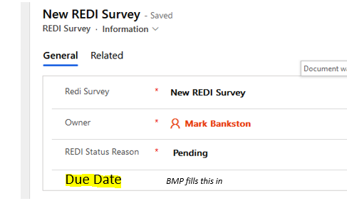

* When the user logs into the portal, they can select a current survey (there will only be one),

* Can you remove the columns Created by and Created on?
* 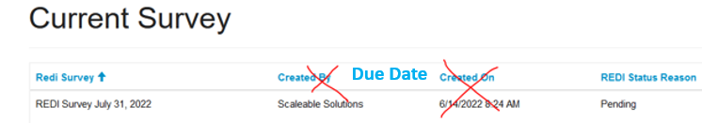
* Please Add **Due Date** column instead.

* Can you make the REDI Survey Name a clickable link to the survey to open it?

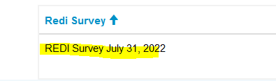

Page Break

* Please remove the “Delete” button from the drop down as we don’t want portal users to have the ability to delete surveys

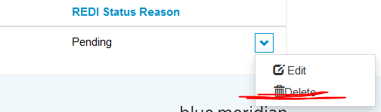

* Is it possible to add a Save button at the bottom of each page?  Users may not know that “Next” button saves their work



* Is it possible to “jump” to a different section by clicking on a tab?

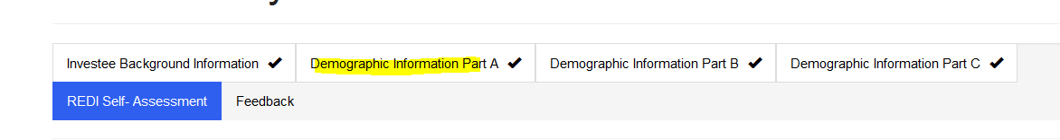

**Survey Form – User Experience**

**Overall comments:  the portal user experience should be as close to the Word document as possible**

* Please update the page header to **REDI Survey Details**



* **Can you adjust the column width for all response fields to half the page (or smaller)?**

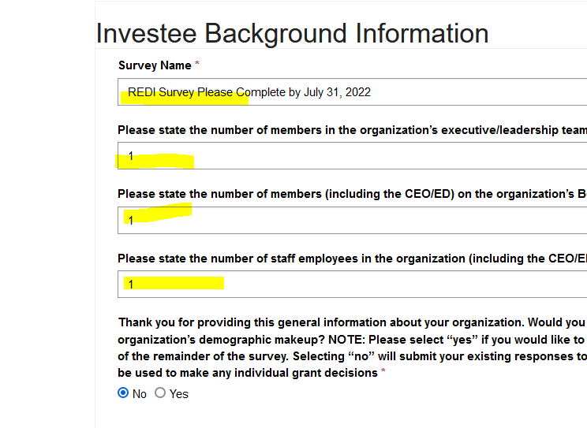

**Survey questions**

**Investee Background Information**

**For question  #6, I selected “No” as the answer, but I did not receive a text box to add a comment.**

* **If the user answers No to this question, a text box should appear to allow them to explain why they answered No.**
* **If the user answers Yes, then the user can proceed to other areas of the survey**

**A: Racial Identity Demographics**

Question #7 – can you move the attribute Unknown so that it displays last?

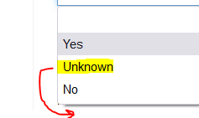

Page Break

* **Question #9**
* **These types of questions need to be displayed to include the description and the table instead of individual answers.  Is it possible to have the response boxes to the right of the field description?**

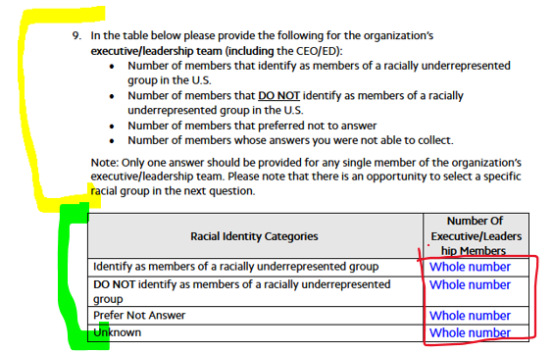

**Currently these questions are displayed individually without a description:**

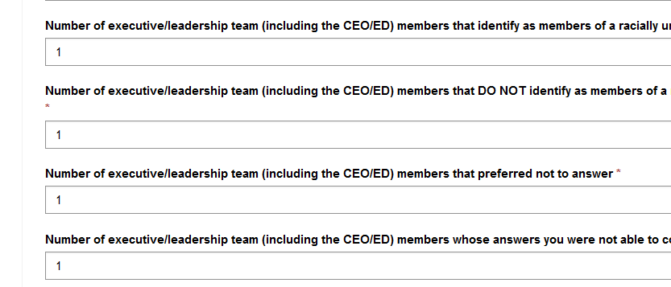

* **I don’t see question #10 in the survey**

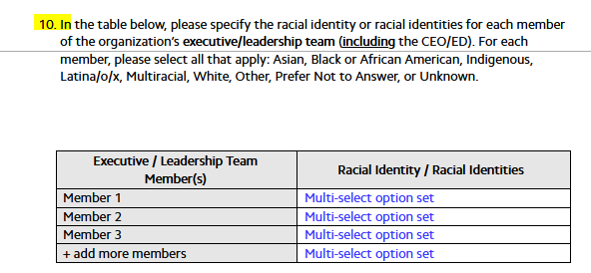

**Question #11 – should be the same as #9 above – a description plus a table instead of individual responses** 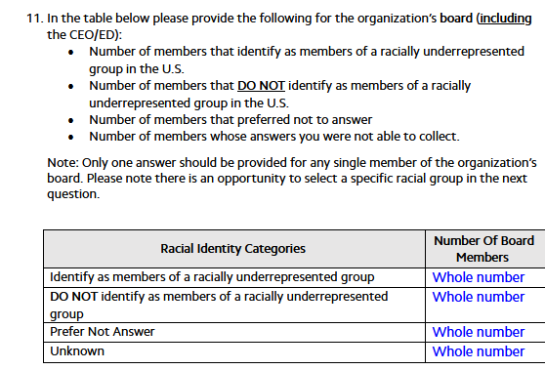

* **I don’t see question #12 in the survey**

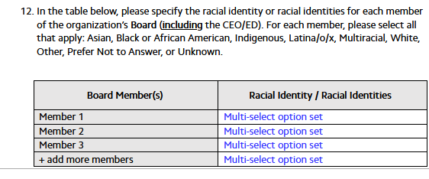

Page Break

* **Question #13 – should be the same as #9 above – a description plus a table instead of individual response boxes**

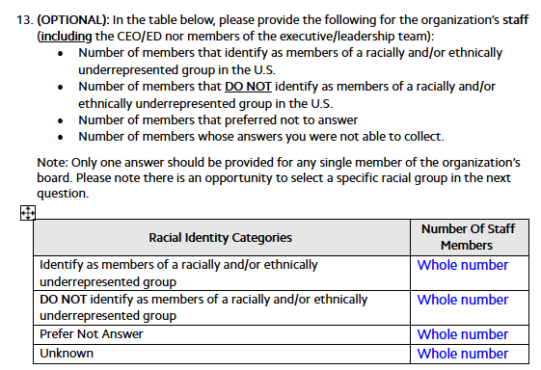

* **Question #14 & #15 – attributes are not correct in the drop-down**
* **Please switch these responses around**
* 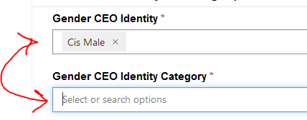

* **Question #16 – should be the same as #9 above – a description plus a table instead of individual response boxes**

* **I don’t see question #17 in the survey**

* **Question #18 – should be the same as #9 above – a description plus a table instead of individual response boxes**

* **I don’t see question #19 in the survey**

* **Question #20 – should be the same as #9 above – a description plus a table instead of individual response boxes**
* **Section III – REDI Self-Assessment**
* **Please emphasize (BOLD) the text where noted in the questions, such as:**

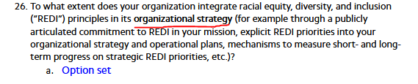

* Progress bar – this looks good, and the Previous Next buttons work great
* Is it possible to highlight the completed sections (tabs) in green #009637?  The checkmark looks good, too, so that can stay
* 